JAVA DEVELOPMENT
WEEK 4 ASSIGNMENT REPORT

Intern Name | Sneha Kesharwani
College | Narula Institute of Technology
Branch | CSE
Assignment Duration | 1 Week (7 days)
Total Marks | 100

Objective:
The objective of this assignment is to understand Java Exception Handling and Collections and apply these concepts through practical programming tasks and a Mini Java Project.

Table of Contents:

No. | Section | Marks
1 | Task 1: Exception Handling — Safe Calculator | 20
2 | Task 2: Collections — Student Names | 15
3 | Task 3: HashSet — Unique Courses | 15
4 | Task 4: HashMap — Student Records | 15
5 | Task 5: StringBuilder — Text Manipulation | 10
6 | Task 6: Mini Java Project — Student Record Manager | 25

Tools and Requirements:
Java JDK and a Java IDE - Visual Studio Code are used to write, compile, and execute the programs. The source files are saved with the .java extension.

Task 1: Exception Handling — Safe Calculator
Objective: Create a Java calculator program that accepts two numbers from the user and performs: Addition Subtraction Multiplication Division Modulus Requirements Handle division by zero using ArithmeticException. Handle invalid input using InputMismatchException. Display meaningful error messages. The program should not terminate unexpectedly when an error occurs.
CODE:
import java.util.InputMismatchException;
import java.util.Scanner;
public class SafeCalculator {
public static void main(String[] args) {
Scanner scanner = new Scanner(System.in);
boolean continueProgram = true;
System.out.println("======================================");
System.out.println(" SAFE CALCULATOR");
System.out.println("======================================");
while (continueProgram) {
try {
System.out.print("\nEnter first number: ");
double num1 = scanner.nextDouble();
System.out.print("Enter second number: ");
double num2 = scanner.nextDouble();
System.out.println("\n----- Results -----");
System.out.println("Addition : " + (num1 + num2));
System.out.println("Subtraction : " + (num1 - num2));
System.out.println("Multiplication : " + (num1 * num2));
// Division by zero handling
if (num2 == 0) {
throw new ArithmeticException("Division by zero is not allowed.");
}
System.out.println("Division : " + (num1 / num2));
System.out.println("Modulus : " + (num1 % num2));
} catch (InputMismatchException e) {
System.out.println("\nERROR: Invalid input!");
System.out.println("Please enter numbers only.");
// Clear invalid input
scanner.nextLine();
} catch (ArithmeticException e) {
System.out.println("\nERROR: " + e.getMessage());
} finally {
System.out.println("\n--------------------------------------");
}
// Ask whether user wants to continue
while (true) {
try {
System.out.print("Do you want to perform another calculation? (yes/no): ");
String answer = scanner.next();
if (answer.equalsIgnoreCase("yes")) {
break;
} else if (answer.equalsIgnoreCase("no")) {
continueProgram = false;
break;
} else {
System.out.println("Please enter only 'yes' or 'no'."); }
} catch (Exception e) {
System.out.println("Unexpected input error occurred.");
scanner.nextLine();
} } }
System.out.println("\nThank you for using Safe Calculator!");
scanner.close();
} }

OUTPUT:
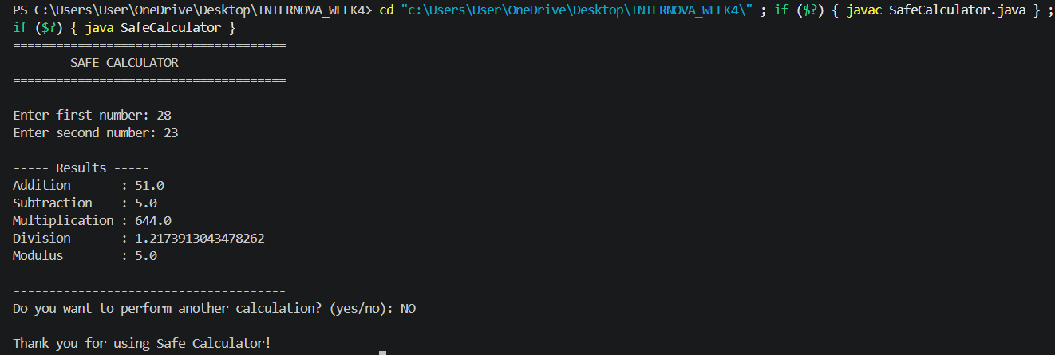

Task 2: Collections — Student Names Objective: Create a Java program using a suitable Collection to store the names of at least 5 students. The program should: Add student names. Display all student names. Remove a student. Search for a particular student. Display the final collection.
CODE:
import java.util.ArrayList;
import java.util.Scanner;
public class StudentNames {
public static void main(String[] args) {
Scanner scanner = new Scanner(System.in);
// Create ArrayList
ArrayList<String> students = new ArrayList<>();
System.out.println("======================================");
System.out.println(" STUDENT NAME MANAGEMENT");
System.out.println("======================================");
// Add students
students.add("Aarav");
students.add("Priya");
students.add("Rahul");
students.add("Sneha");
students.add("Ananya");
System.out.println("\nStudents after adding:");
displayStudents(students);
// Add another student
students.add("Rohan");
System.out.println("\nAfter adding Rohan:");
displayStudents(students);
// Search for a student
System.out.print("\nEnter student name to search: ");
String searchName = scanner.nextLine();
if (students.contains(searchName)) {
System.out.println(searchName + " is present in the collection.");
} else {
System.out.println(searchName + " is not present in the collection.");
}
// Remove a student
System.out.print("\nEnter student name to remove: ");
String removeName = scanner.nextLine();
if (students.remove(removeName)) {
System.out.println(removeName + " has been removed successfully.");
} else {
System.out.println(removeName + " was not found.");
}
// Final collection
System.out.println("\nFinal Student Collection:");
displayStudents(students);
scanner.close();
}
public static void displayStudents(ArrayList<String> students) {
for (String student : students) {
System.out.println("- " + student);
}
}
}
OUTPUT:
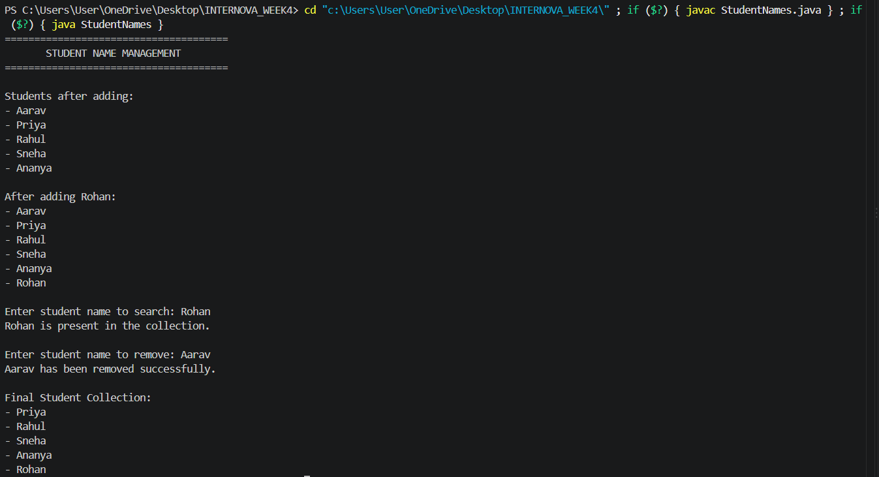

Task 3: HashSet — Unique Courses
Objective: Create a Java program using HashSet to store course names. Requirements Add at least 7 course entries. Include duplicate course names. Display the final HashSet. Demonstrate that duplicate values are not stored. Search for a particular course.
CODE:
import java.util.HashSet;
import java.util.Scanner;
public class UniqueCourses {
public static void main(String[] args) {
Scanner scanner = new Scanner(System.in);
// Create HashSet
HashSet<String> courses = new HashSet<>();
System.out.println("======================================");
System.out.println(" UNIQUE COURSES");
System.out.println("======================================");
// Add courses
courses.add("Java");
courses.add("Python");
courses.add("Data Structures");
courses.add("Database Management");
courses.add("Web Development");
courses.add("Cloud Computing");
courses.add("Artificial Intelligence");
// Duplicate entries
courses.add("Java");
courses.add("Python");
courses.add("Java");
System.out.println("\nCourses after adding entries:");
displayCourses(courses);
System.out.println("\nTotal unique courses: " + courses.size());
// Search course
System.out.print("\nEnter a course to search: ");
String searchCourse = scanner.nextLine();
if (courses.contains(searchCourse)) {
System.out.println(searchCourse + " is available in the HashSet.");
} else {
System.out.println(searchCourse + " is not available in the HashSet.");
}
System.out.println("\nNotice:");
System.out.println("Duplicate course names were added,");
System.out.println("but HashSet stored each course only once.");
scanner.close();
}
public static void displayCourses(HashSet<String> courses) {
for (String course : courses) {
System.out.println("- " + course);
}
}
}
OUTPUT:
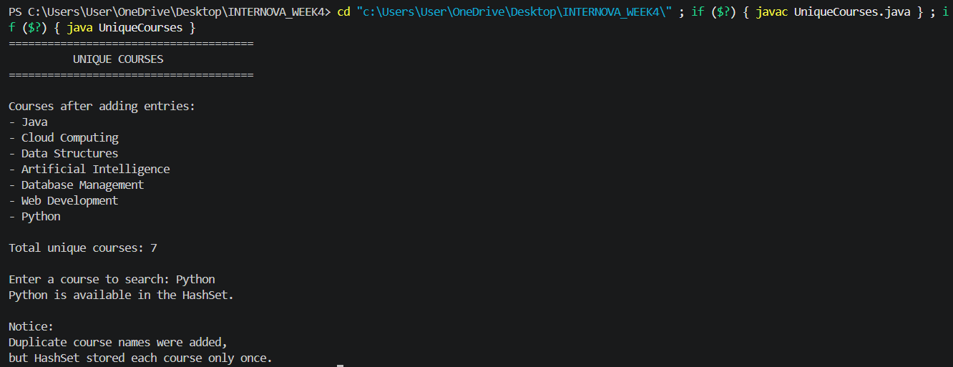

Task 4: HashMap — Student Records
Objective: Create a Java program using HashMap to store student records. Use: Key: Student ID Value: Student Name The program should: Add at least 5 student records. Display all records. Search for a student using Student ID. Remove a student record. Display the updated records.
CODE:
import java.util.HashMap;
import java.util.Map;
import java.util.Scanner;
public class StudentRecords {
public static void main(String[] args) {
Scanner scanner = new Scanner(System.in);
// Create HashMap
HashMap<Integer, String> studentRecords = new HashMap<>();
System.out.println("======================================");
System.out.println(" STUDENT RECORDS");
System.out.println("======================================");
// Add student records
studentRecords.put(101, "Aarav Sharma");
studentRecords.put(102, "Priya Singh");
studentRecords.put(103, "Rahul Verma");
studentRecords.put(104, "Sneha Gupta");
studentRecords.put(105, "Ananya Das");
// Display all records
System.out.println("\nAll Student Records:");
displayRecords(studentRecords);
// Search by Student ID
try {
System.out.print("\nEnter Student ID to search: ");
int searchId = scanner.nextInt();
if (studentRecords.containsKey(searchId)) {
System.out.println( "Student Found: " + studentRecords.get(searchId));
} else {
System.out.println( "No student found with ID: " + searchId);
}
} catch (Exception e) {
System.out.println("ERROR: Please enter a valid numeric Student ID.");
scanner.nextLine();
}
try {
System.out.print("\nEnter Student ID to remove: ");
int removeId = scanner.nextInt();
if (studentRecords.containsKey(removeId)) {
String removedStudent = studentRecords.remove(removeId);
System.out.println(
removedStudent +
" with ID " +
removeId +
" has been removed." );
} else {
System.out.println("No student found with ID: " + removeId);
}
} catch (Exception e) {
System.out.println("ERROR: Please enter a valid numeric Student ID.");
}
// Updated records
System.out.println("\nUpdated Student Records:");

displayRecords(studentRecords);
scanner.close();
}
public static void displayRecords(
HashMap<Integer, String> studentRecords) {
if (studentRecords.isEmpty()) {
System.out.println("No student records available.");
return;
}
for (Map.Entry<Integer, String> entry :
studentRecords.entrySet()) {
System.out.println(
"Student ID: " + entry.getKey() +
" | Name: " + entry.getValue()
);
}
}
}
OUTPUT:
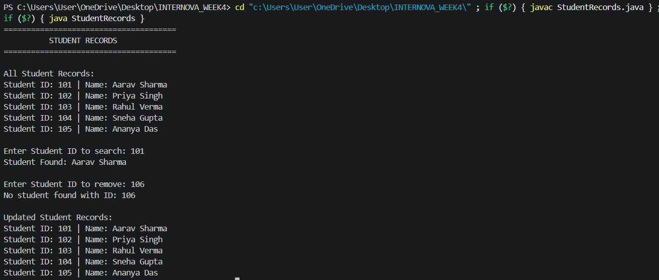

Task 5: StringBuilder — Text Manipulation
Objective: Create a Java program using StringBuilder. Perform the following operations: Create a string. Append additional text. Insert text at a specific position. Replace a portion of the text. Reverse the final string. Display the result after performing the operations.
CODE:
public class StringBuilderDemo {
public static void main(String[] args) {
System.out.println("======================================");
System.out.println(" STRINGBUILDER DEMO");
System.out.println("======================================");
// Create StringBuilder
StringBuilder text = new StringBuilder("Java Programming");
System.out.println("\nOriginal Text:");
System.out.println(text);
// Append
text.append(" is interesting.");
System.out.println("\nAfter Append:");
System.out.println(text);
// Insert
text.insert(5, "Core ");
System.out.println("\nAfter Insert:");
System.out.println(text);

// Replace
text.replace(0, 4, "Advanced");
System.out.println("\nAfter Replace:");
System.out.println(text);
// Reverse
text.reverse();
System.out.println("\nAfter Reverse:");
System.out.println(text);
System.out.println("\n======================================");
System.out.println("StringBuilder operations completed!");
System.out.println("======================================");
}
}
OUTPUT:
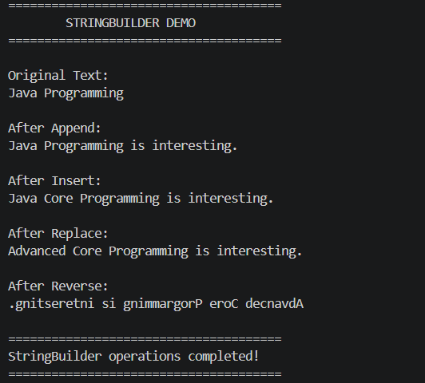

Task 6: Mini Java Project — Student Record Manager
Objective: Build a console-based Student Record Manager using the concepts covered in Week 4. Main Menu ===== Student Record Manager ===== 1. Add Student 2. View Students 3. Search Student 4. Remove Student 5. Display Unique Courses 6. Exit Enter your choice: 1. Add Student Accept: Student ID Student Name Course Age Store the student records using an appropriate Collection. Student ID should be unique. 2. View Students Display all stored student records in a properly formatted manner. 3. Search Student Allow the user to search for a student using Student ID. If the student does not exist, display an appropriate message. 4. Remove Student Allow the user to remove a student using Student ID. Display a confirmation message after successful removal. 5. Display Unique Courses Use HashSet to display all unique course names stored in the system. If multiple students belong to the same course, the course should appear only once. 6. Exception Handling Handle appropriate errors such as: Invalid menu choice Invalid numeric input Invalid Student ID Searching for a non-existing student The application should not crash unexpectedly. 7. StringBuilder Use StringBuilder meaningfully for formatting or constructing student information/output.
CODE:
import java.util.HashMap;
import java.util.HashSet;
import java.util.Map;
import java.util.Scanner;
public class StudentRecordManager {
private static HashMap<Integer, Student> students =
new HashMap<>();
private static Scanner scanner = new Scanner(System.in);
public static void main(String[] args) {
boolean running = true;
System.out.println("==============================================");
System.out.println(" STUDENT RECORD MANAGER");
System.out.println("==============================================");
while (running) {
displayMenu();
try {
System.out.print("Enter your choice: ");
int choice = scanner.nextInt();
scanner.nextLine();
switch (choice) {
case 1:
addStudent();
break;

case 2:
viewStudents();
break;
case 3:
searchStudent();
break;
case 4:
removeStudent();
break;
case 5:
displayUniqueCourses();
break;
case 6:
running = false;
System.out.println(
"\nThank you for using Student Record Manager!"
);
break;
default:
System.out.println(
"\nERROR: Invalid menu choice!"
);
System.out.println("Please select a number between 1 and 6." );
}
} catch (Exception e) {
System.out.println(
"\nERROR: Invalid input!" );
System.out.println(
"Please enter a valid numeric choice."
);
scanner.nextLine();
}
System.out.println();
}
scanner.close();
}
private static void displayMenu() {
System.out.println("----------------------------------------------");
System.out.println("1. Add Student");
System.out.println("2. View Students");
System.out.println("3. Search Student");
System.out.println("4. Remove Student");
System.out.println("5. Display Unique Courses");
System.out.println("6. Exit");
System.out.println("----------------------------------------------");
}
private static void addStudent() {
System.out.println("\n========== ADD STUDENT ==========");
try {
System.out.print("Enter Student ID: ");
int id = scanner.nextInt();
scanner.nextLine();
// Validate ID
if (id <= 0) {
System.out.println(
"ERROR: Student ID must be a positive number."
);
return;
}
if (students.containsKey(id)) {
System.out.println(
"ERROR: Student ID " + id +
" already exists."
);
System.out.println(
"Student ID must be unique." );
return;
}
System.out.print("Enter Student Name: ");
String name = scanner.nextLine().trim();
if (name.isEmpty()) {
System.out.println(
"ERROR: Student name cannot be empty."
);
return;
}
System.out.print("Enter Course: ");
String course = scanner.nextLine().trim();
if (course.isEmpty()) {
System.out.println(
"ERROR: Course cannot be empty."
);
return;
}
System.out.print("Enter Age: ");
int age = scanner.nextInt();
scanner.nextLine();
if (age <= 0 || age > 100) {

System.out.println(
"ERROR: Please enter a valid age."
);
return;
}
// Create Student object
Student student =
new Student(id, name, course, age);
// Store in HashMap
students.put(id, student);
System.out.println(
"\nStudent added successfully!" );
} catch (java.util.InputMismatchException e) {
System.out.println(
"ERROR: Invalid input." );
System.out.println(
"Student ID and Age must be numeric."
);
scanner.nextLine();
} catch (Exception e) {
System.out.println(
"ERROR: Unable to add student."
);

scanner.nextLine();
}
}
private static void viewStudents() {
System.out.println("\n========== ALL STUDENTS ==========");
if (students.isEmpty()) {
System.out.println(
"No student records available."
);
return;
}
System.out.println(
"--------------------------------------------------" );
System.out.printf(
"%-10s %-20s %-20s %-5s%n",
"ID",
"Name",
"Course",
"Age"
);

System.out.println(
"--------------------------------------------------"
);
for (Student student : students.values()) {
StringBuilder output = new StringBuilder();
output.append(
String.format(
"%-10d %-20s %-20s %-5d",
student.getId(),
student.getName(),
student.getCourse(),
student.getAge()
)
);
System.out.println(output);
}
System.out.println(
"--------------------------------------------------"
);
System.out.println(
"Total Students: " + students.size()
);
}
private static void searchStudent() {

System.out.println("\n========== SEARCH STUDENT ==========");
try {
System.out.print("Enter Student ID: ");
int id = scanner.nextInt();
scanner.nextLine();
if (id <= 0) {
System.out.println(
"ERROR: Student ID must be positive."
);
return;
}
if (students.containsKey(id)) {
Student student = students.get(id);
StringBuilder result =
new StringBuilder();
result.append("\nStudent Found!\n");
result.append("------------------------------\n");
result.append("Student ID : ")
.append(student.getId())
.append("\n");
result.append("Name : ")
.append(student.getName())
.append("\n");
result.append("Course : ")
.append(student.getCourse())
.append("\n");
result.append("Age : ")
.append(student.getAge())
.append("\n");
result.append("------------------------------");
System.out.println(result);
} else {
System.out.println("Student with ID " + id + " does not exist.");
}
} catch (java.util.InputMismatchException e) {
System.out.println(
"ERROR: Student ID must be numeric." );
scanner.nextLine();
}
}
private static void removeStudent() {
System.out.println("\n========== REMOVE STUDENT ==========");
try {
System.out.print("Enter Student ID: ");
int id = scanner.nextInt();
scanner.nextLine();
if (id <= 0) {
System.out.println( "ERROR: Student ID must be positive.");
return;
}
if (students.containsKey(id)) {
Student removedStudent =
students.remove(id);
System.out.println("\nStudent removed successfully!");
System.out.println( "Removed Student: " +
removedStudent.getName());
System.out.println( "Student ID: " + id );
} else {
System.out.println(
"Student with ID " +
id +
" does not exist." );
}
} catch (java.util.InputMismatchException e) {
System.out.println(
"ERROR: Student ID must be numeric.");
scanner.nextLine();
}
}
private static void displayUniqueCourses() {
System.out.println(
"\n========== UNIQUE COURSES ==========");
if (students.isEmpty()) {
System.out.println(
"No students available.");
return;
}
HashSet<String> uniqueCourses =
new HashSet<>();
for (Student student : students.values()) {
uniqueCourses.add(
student.getCourse()
); }
System.out.println(
"\nUnique Courses:");
System.out.println(
"------------------------------");
for (String course : uniqueCourses) {
System.out.println(
"- " + course );
}
System.out.println( "------------------------------");
System.out.println("Total Unique Courses: " +
uniqueCourses.size() );
}
static class Student {
private int id;
private String name;
private String course;
private int age;
public Student(
int id,
String name,
String course,
int age) {
this.id = id;
this.name = name;
this.course = course;
this.age = age;}
public int getId() {
return id;
}
public String getName() {
return name;
}
public String getCourse() {
return course;
}
public int getAge() {
return age;
} } }
OUTPUT:
